Sub Code : 18CSC302J

CSE F1

Computers Network

REG No. 1811003010344

Name : Vikash Mishra

**EXPERIMENT-8**

**HALF DUPLEX CHAT USING TCP/IP**

**AIM:** To implement a Half Duplex chat using TCP/IP.

**CODING:**

**SERVER:**

#server side

from socket import *

server_port = 5000

server_socket = socket(AF_INET,SOCK_STREAM)

server_socket.bind(('',server_port))

server_socket.listen(1)

print ("Welcome: The server is now ready to receive")

connection_socket, address = server_socket.accept()

while True:

sentence = connection_socket.recv(2048).decode()

print('>> ',sentence)

message = input(">> ")

connection_socket.send(message.encode())

if(message == 'q'):

connectionSocket.close()

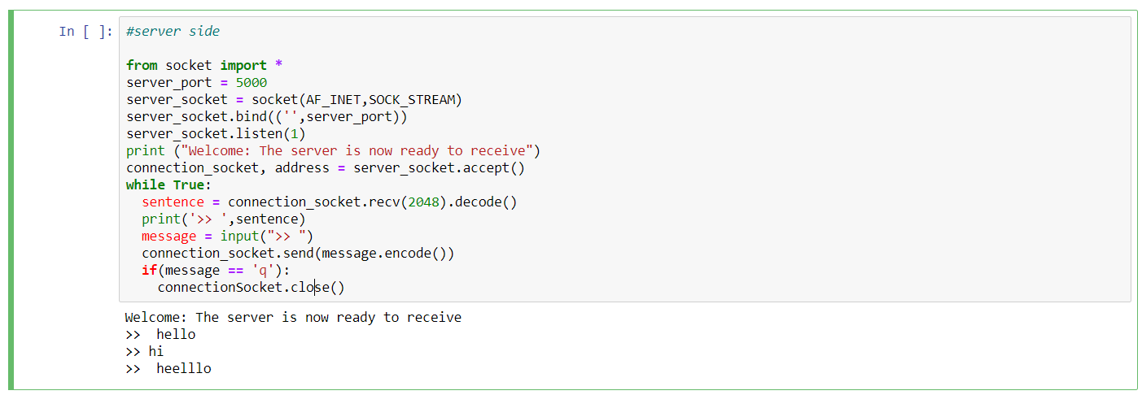

**CODING:**

**CLIENT:**

#Client side

from socket import *

server_name = 'localhost'

server_port = 5000

client_socket = socket(AF_INET, SOCK_STREAM)

client_socket.connect((server_name,server_port))

while True:

sentence = input(">> ")

client_socket.send(sentence.encode())

message = client_socket.recv(2048)

print (">> ", message.decode())

if(sentence == 'q'):

client_socket.close()

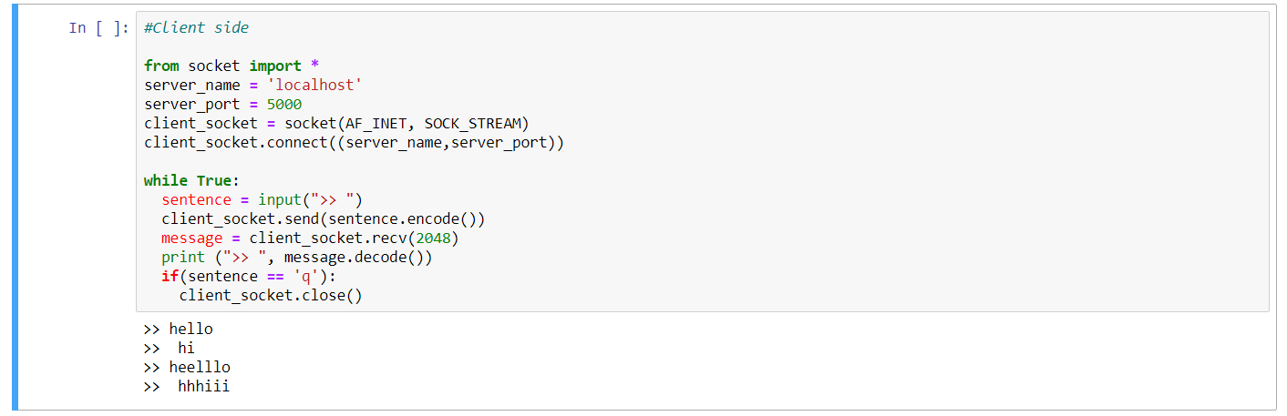

Sub Code : 18CSC302J

CSE F1

Computers Network

REG No. 1811003010344

Name : Vikash Mishra